25th February 2018

Today I started off by finishing off the codebook optimisation for one octave. Now I have the codebook optimisation graph:
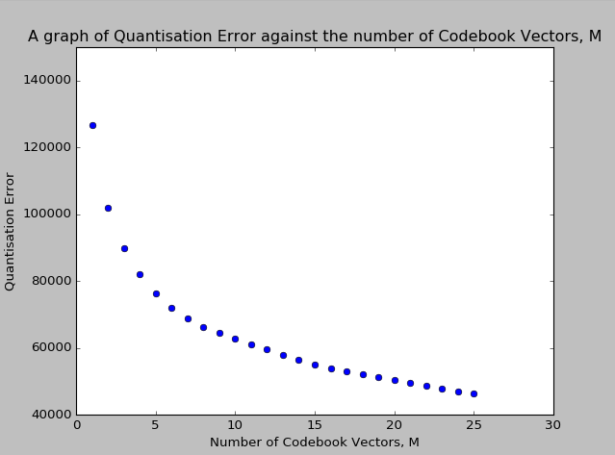

As can be seen, I believe the knee to be at M = 6, so I will now retrain the model with M = 6, among everything else.

It is now running (15:17), while I wait, I’m gonna clean up the predictNext function and mess with the tilted distribution idea.
The tilted distribution thing only required a one line modification, so that’s alright.
I’m gonna move back to the dissertation for a bit now there.
Trained after 97 iterations, with 71937.15235523247 quantisation error

